

NHS NATIONAL SERVICES SCOTLAND

JOB DESCRIPTION
1. JOB DETAILS
Job Title |  | Consultant in Clinical Transfusion Microbiology/Head of Scottish National Blood Transfusion Service (SNBTS) National Microbiology Reference Unit (NMRU)
Immediate Senior Officer/ Line Manager |  | Medical Director SNBTS
Department |  | NMRU
SBU |  | Scottish National Blood Transfusion Service
Location |  | Jack Copland Centre, Edinburgh
CAJE Reference |  | JDSNBTSS206
2. JOB PURPOSE
- To manage the Microbiology Reference Unit and to ensure the effective delivery of a high quality specialised clinical blood transfusion microbiology laboratory service.
- To provide specialist microbiology advice to SNBTS and external colleagues as required.
- To ensure that microbiology referrals are reported within agreed timescales to meet clinical and blood safety requirements, ensuring that results are as accurate as possible. Microbiology specificities include hepatitis viruses (HAV, HBV, HCV & HEV), human immunodeficiency virus (HIV), syphilis, human T cell leukaemia virus (HTLV), West Nile virus, human parvovirus B19, malaria, T. cruzi and T. gondii. Emerging agents, which pose a risk for transfusion and/or transplantation, may need evaluation for implementation of testing in the future.
- To advise SNBTS of potential and emerging infection risks, through interacting with relevant bodies including the UK Blood Services, Joint United Kingdom Blood Transfusion and Tissue Transplantation Services Professional Advisory Committee (JPAC) through its Standing Advisory Committee for Transfusion Transmitted Infections (SACTTI), European Blood Alliance Emerging Infectious Disease (EBA-EID), European Centre for Disease Prevention & Control [ECDC], UK Health Security Agency (UKHSA) and Public Health Scotland (PHS).
- To Chair the SNBTS Microbiology Test Evaluation Group (MTEG) which oversees evaluations of potential microbiological assays for donor testing and confirmation purposes and make recommendations to SNBTS Clinical Governance and Safety Group (CGSG) regarding their suitability for use in SNBTS.
- To monitor the performance of microbiology tests used routinely by SNBTS and the frequency and epidemiological of confirmed microbiology positives in Scottish donors, producing regular reports for SNBTS CGSG and NHSBT/UKHSA Epidemiology Unit.
- To report ‘reportable’ microbiological infections to PHS and relevant Health Protection Units in a timely manner.
- To develop the role to become part of the senior professional team within SNBTS, potentially through membership of external committees (e.g. SACTTI) to ensure SNBTS is provided with the best possible microbiological advice.
- Lead research in areas of microbiology assay development and of new, emerging and /or re-emerging microbiological agents potentially important for blood, tissue and/or cell transfusion in Scotland and the UK.
3. DIMENSIONS
The post-holder will be responsible for the professional leadership of the SNBTS Microbiology Reference Unit and will provide national leadership in this field across SNBTS, advising the SNBTS Senior Management on strategic issues relating to the provision of these services.
The post-holder will be required to work autonomously, within professional guidelines.
The post-holder will provide specialist teaching including development of training programmes to clinical and scientific staff within their own discipline and for other disciplines across Scotland.
The post-holder is the budget holder for the SNBTS NMRU (current total budget of £1.1 million) and responsible for the procurement or maintenance of all physical assets or supplies for NMRU
The NMRU is staffed by 14.2 WTE.
4. ORGANISATION CHART
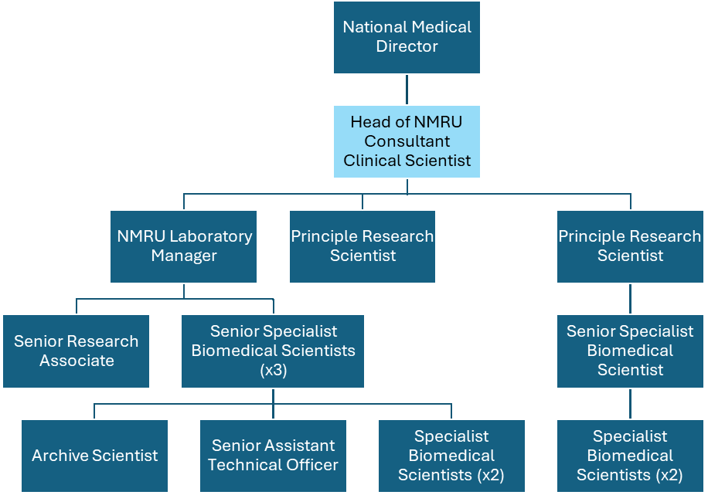
5. ROLE OF THE DEPARTMENT
The SNBTS exists to meet the transfusion needs of patients in Scotland. The NMRU is a highly specialised unit providing microbiology confirmatory, reference and screening services for a range of internal (SNBTS Processing & Testing, Tissues, Cells & Advanced Therapeutics, Scottish Centre for Regenerative Medicine, Clinical Apheresis Unit) and external customers (Northern Ireland Blood Transfusion Service, Irish Blood Transfusion Service, German Stem Cell Bank, Scottish Hospital Trusts, NHS Blood and Transplant).
Samples that are repeat-reactive in donor screening assays for Hepatitis B virus, Hepatitis C virus, Hepatitis E virus, Human immunodeficiency virus I&II, Human T cell leukaemia virus I&II, Treponema pallidum (Syphilis), WNV and Malaria are referred to NMRU where they are further tested, following specific confirmatory serological and molecular algorithms developed in the NMRU, to determine if the reactivity is reflective of a true infection. Testing can provide additional information to the medical team regarding infection stage and timeline of infection to assist donor counselling.
NMRU also acts as a screening service for referrals sent to NMRU for a variety of reasons; small scale testing required (T. cruzi, T. gondii), tests not available on routine testing platforms (and which may require immediate implementation), samples out with specification for routine testing (low-volume samples, samples obtained from cadaveric donors or not centrifuged within IFU timescales).
The NMRU provides advice on confirmatory testing for infections that are or may be transmitted through blood transfusion, tissue use and organ transplantation. As the national reference service for these aspects the role requires benchmarking and interaction with other national services.
6. KEY RESULT AREAS

Timely delivery of advice and results for infectious disease assays on potentially infected blood and tissue donations.

Develops and maintain an infectious Marker Epidemiological database and inventory of infectious donations.

- Actively participates in the SNBTS CGSG, which develops new policies for SNBTS and monitors current activity.

- Responsible for policy implementation in the SNBTS NMRU, and for discrete policy or service development within NMRU e.g. development of confirmatory algorithms for each infectious agent considered, considering available (e.g. UKCA/CE marked) assays.

- Represent SNBTS on relevant national and international committees (e.g. JPAC Standing Advisory Committee on Transfusion Transmitted Infections (SACTTI).

- Manages the budget for the NMRU Cost Centre (Current NMRU budget of £1.1 million), responsible for the procurement or maintenance of all physical assets or supplies for NMRU, to ensure effective, efficient and accountable use of resources.

- Recruit, lead, manage and develop the NMRU staff (14.2 WTE) and ensure that the NMRU is adequately provided with trained, motivated staff who meet SNBTS requirements. The post-holder should meet or exceed relevant SNBTS targets for effective staff governance.

- Responsible for the delivery of specialist teaching or devising of training and development programmes.

- Responsible for ensuring minutes are taken minutes at various meetings e.g. SNBTS MTEG, NMRU Lab Meetings and other SNBTS and UK meetings as required.

- Lead research and development for studies to evaluate (and design and improve if required) assays for the detection of transfusion transmitted pathogens.

- To design and report on serological and molecular surveillance studies to provide information on epidemiology of new, emerging and /or re-emerging microbiological agents in Scottish donors, as required, which can be used to assess the safety risk for SNBTS supply chains.

- To lead research, within SNBTS and through external collaborations, for the study of new, emerging and /or re-emerging microbiological agents which may impact on the safety of the blood supply in Scotland and the UK.

7. ASSIGNMENT AND REVIEW OF WORK/ DECISIONS AND JUDGEMENTS
The output from the post-holder will largely be self-generated in response to the needs of SNBTS. This will involve planning, setting priorities and monitoring output for both the post-holder and the NMRU.
The post-holder can make decisions, without need to refer to any other Manager, and can expect other Managers to provide any necessary information needed by the post-holder to ensure that an informed judgement can be reached.
The post-holder monitors NMRU, SNBTS and UK microbiology statistics to determine trends and reports on NMRU result turnaround times to CGSG.
The post-holder is responsible for the development of confirmatory algorithms for each of the microbiological specifications. As and when tests become unavailable, the postholder is required to plan alternative strategies.
The SNBTS Medical Director will agree the objectives with the post-holder. These objectives will be reviewed every 6 months.
The post-holder will be expected to lead the planning of major quality initiatives and to participate in other projects. The post-holder will be accountable for progress on these developments.
The post-holder will be expected to provide regular reports, including an annual summary, for the benefit of the SNBTS Medical Director and SNBTS CGSG.
8. COMMUNICATIONS AND WORKING RELATIONSHIPS
Internal Communications
SNBTS Medical Director (6 times/year)
SNBTS Clinical Governance & Safety Group (monthly)
SNBTS MTEG (2-3/year) (Chair)
SNBTS Infection Control (quarterly)
SNBTS project operational, clinical and/or steering groups (as required)
NMRU & Quality meetings (monthly)
SNBTS Operational Management Group (or deputy) (monthly)
NMRU finance meeting (monthly)
Medical and Scientific QPR (quarterly)
Medical and Clinical Scientists Meeting (quarterly)

External Communications
Scottish Diagnostic Virology Group (biannual)
NHSBT Microbiology Services Clinical Group (quarterly)
NHSBT Kit Evaluation Group (as required)
British Blood Transfusion Society Microbiology Special Interest Group (annual)
Current post-holder attends:
JPAC Standing Advisory Committee for Transfusion Transmitted Infections (SACTTI) (3 per year by invite)
JPAC SACTTI Parasite committee (annually by invite)
JPAC SACTTI Horizon Scanning telcons (monthly by invite)
JPAC Standing Advisory Committee for Tissues (SACT) (3-6 per year by invite)
Various commercial companies (as required)

The post-holder may also make presentations (lectures, posters, papers) to various local, national and international meetings/journals.
9. MOST CHALLENGING PART OF THE JOB
- To provide timely reporting of the likely infectious status of donations for several agents in a timely and cost-effective manner.
- To maintain a current knowledge of microbiological risks for SNBTS (e.g. through SACCTI, ECDC etc.).
- To maintain a current knowledge of available technologies for detection of infectious agents, both those of current concern and emerging agents.
10. Systems
- Develops and maintains infectious marker epidemiological databases and inventory of infectious donations.
- Occasional requirement to create or format databases or spreadsheets using computerised systems.
- For staff within SNBTS, MRU utilises TURAS, e-expenses and SSTS (or equivalent) to undertake and record PDP and objective setting, expenses and time worked retrospectively.
- Use of current computerised system (PECOS) to order goods and services.
- Routine use of office suite of software (Word, Powerpoint, Access, Excel databases).
11. WORKING ENVIRONMENT AND EFFORT
Physical Effort
- Post involves mainly desk work, but occasional requirement for precise laboratory or autoclave work; occasional road and air travel.
- A highly developed level of skill is required for performing some of the assays within MRU. MRU relies heavily on manual testing usually microtitre ELISAs and molecular assays that require to be set up within strict time schedules but more importantly with no possibility of carry-over. The post-holder is expected to have knowledge and expertise in such assays and advise on their use although requirement to performing these tests will be infrequent.
Mental Effort
- Approximately 50% of time in writing specialised reports or attending meetings; rest of time required for NMRU laboratory functions & routine reporting.
- As a Line Manager undertakes staff appraisals and any required disciplinary actions.
Emotional Effort
- Pressure to deliver confirmatory diagnostic assay results that may have a life-changing impact in infected donors, rapidly and accurately.
- As a Line Manager the post-holder is expected to undertake objective appraisal and objective setting (twice a year) and to deliver disciplinary processes if required. In times of change may need to occasionally impart bad news to staff.
- Laboratory diagnosis in transfusion cases where blood or tissues has been imputed as the potential cause of a new infection. This occasionally may extend to providing written or oral evidence to inquiries and/or courts.
12. ENVIRONMENTAL / WORKING CONDITIONS & MACHINERY AND EQUIPMENT
- Occasional exposure to known highly infectious materials.
13. QUALIFICATIONS AND/OR EXPERIENCE SPECIFIED FOR THE POST
- Holds a PhD or equivalent in Transfusion Microbiology or a related scientific field.
- The post-holder must have demonstrable relevant practical experience in a Microbiology Laboratory, preferably with specific knowledge of working in a Transfusion Microbiology Laboratory.
- The post-holder is expected to be state registered as a Clinical Scientist with the Health and Care Professions Council (HCPC).
- The post-holder is expected to have an active publication record and to have obtained, or be working towards, Fellowship of the Royal College or Pathologists.
- Demonstration of CPD
- Broad range of theoretical knowledge in the field of Transfusion Microbiology and more specific specialised knowledge of the types of assays used within the NMRU.
- Knowledge and ability to accurately interpret complex algorithms used in the confirmation of repeatedly reactive test referrals. Ability to explain erroneous or unexpected results and troubleshoot.
- A highly developed level of skill may be required for performing some of the assays within NMRU. NMRU relies heavily on manual testing usually using mictrotitre ELISAs and molecular assays (e.g. PCR) that require to be set up within strict time schedules but more importantly with no possibility of carry-over/contamination. The post-holder is expected to have expertise in such assays and advise on their use and result interpretation.
14. JOB DESCRIPTION AGREEMENT
A separate job description will need to be signed off by each post-holder to whom the job description applies.

Post-holder Signature: |  |  | Date:
Post-holder Print:
Manager Signature: |  |  | Date:
Manager Print:
Manager Title:

